Lesson Plan Title: Digital Storytelling Length: 2 class periods (6 hours)

Pre-Assessment:
This will need to be done prior to teaching your lesson. Outline the method you will use to determine the skill/knowledge level of your students based on the concepts/enduring understandings/objectives of the lesson. (Hint: turn these into questions.) Be specific in describing what you would recognize as proficient skill/knowledge.
As a pre-assessment, we will be focusing on the previous projects done for peer teaching. Our lesson will be based on technology and using a computer program so we will be taking note of how well students are using technology in previous lessons and assessing their final projects.
-Did the student get frustrated while using photoshop?
-Did the student have questions about the program?
-Did the student successfully complete the previous projects?
-Did the student enjoy the process of photoshop?

Performance:
What will students accomplish as a result of this lesson? This can be presented to students in the form of a story. In this narrative the students take on a role and create a learning product about a specific topic for a certain audience. (RAFT – Role / Audience / Format / Topic)
You are an author that has just been offered a job to create a story. You must take a classic fable or fairy tale and make it for a contemporary audience. You will be working in pairs so make sure you and your partner are both on board to recreate the same fable or fairy tale. The catch is that it is digital. There are no pages, no physical book, just a computer and an animation program. Your finished product will be shared with the world.

Concepts:
List the big ideas students will be introduced to in the lesson. These ideas are universal, timeless and transferrable. Examples of concepts used in art might include: Composition, Patterns, Technique, Rhythm, Paradox, Influence, Style, Force, Culture, Space/Time/Energy, Line, Law/Rules, Value, Expressions, Emotions, Tradition, Symbol, Movement, Shape, Improvisation, and Observation Look for concepts in the standards, content specific curriculum, etc.
Technology
Composition
Culture
Movement

Enduring Understanding (s):
Enduring Understandings show a relationship between two or more concepts; connected with an active verb. The best enduring understandings not only link two or more concepts; but demonstrate why this relationship is important. Like concepts, they are timeless, transferrable and universal. Align Standards, Prepared Graduate Competencies (PGCs) and Grade Level Expectations (GLEs) to Enduring Understandings.
Decisions about artmaking can be developed through engagement with art can lead to understanding and appreciation of self, others, the natural world, and constructed environments.

Standards: (All lessons should address all standards.)
1. Observe and Learn to Comprehend
2. Envision and Critique to Reflect
3. Invent and Discover to Create
4. Relate and Connect to Transfer

Objectives/Outcomes/Learning Targets:
Objectives describe a learning experience with a condition → behavior (measurable) → criterion. Aligned to: Bloom’s – Standards – GLEs - Art learning and, when appropriate, Numeracy, Literacy and Technology. Should be written as: Objective. (Bloom’s: _____ - Standard: _____ - GLE: _____ -Art learning: _____ -Numeracy, Literacy, and/or Technology)
Given a worksheet, TSWBAT, create a storyline that will be followed in their video.
Blooms: Applying Standard: create - GLE: 2 -Art Learning: Ideation - Literacy
Given a sharpie and paper, TSWBAT, use line to create an expressive character.
Blooms: Creating Standard: create- GLE:2 -Art Learning: ICEF
Given the program VideoScribe, TSWBAT, create a whiteboard video that recreates a fable or fairytale.
Blooms: Creating Standard: Create - GLE: 1 -Art Learning: Media Techniques Technology)
Given sample videos, TSWBAT, identify important aspects of storytelling in cultures.
Blooms: Analyzing Standard: Transfer- GLE: 2 -Art Learning: Art History/ Culture
Given reflection worksheet, TSWBAT, assess their own and their peer’s final videos.
Blooms: Evaluating Standard: Reflect - GLE: 3 -Art learning: Reflect/Assess

Differentiation:
Explain specifically how you have addressed the needs of exceptional students at both end of the skill and cognitive scale. Describe the strategies you will use for students who are already proficient and need growth beyond what you have planned for the rest of the class, as well as modifications for students with physical and/or cognitive challenges. Students must still meet the objectives.

Differentiation:  (Multiple means for students to access content and multiple modes for student to express understanding.) | Access (Resources and/or Process) | Expression (Products and/or Performance)
 | We will install the video program to the school’s laptops to make sure that it is accessible to all students. | Students will be able to pick between a fable or fairytale and choose which one they want to recreate.
Extensions for depth and complexity: | Access (Resources and/or Process) | Expression (Products and/or Performance)
 | Students will be asked to create a storyline. | Students will have the option to  import their own images into their  videos.

Literacy:
List terms (vocabulary) specific to the topic that students will be introduced to in the lesson and describe how literacy is integrated into the lesson.
Digital Storytelling
VideoScribe
Students will be creating stories using the literary elements of a story.

Materials:
Must be grade level appropriate. List everything you will need for this lesson, including art supplies and tools. (These are the materials students will use.) List all materials in a bulleted format.
Brainstorming worksheets
Storyline worksheets
Computers
VideoScribe program
Projector
Smart Board
Reflection Worksheets
Paper
Sharpies

Resources:

List all visual aids and reference material (books, slides, posters, etc. Be specific; include title, artist, etc. Make reference to where the material can be found. (These are the resources used by the teacher to support/develop the lesson.) List all resources in a bulleted format.
https://www.youtube.com/watch?v=MnA4u9CaK7A
https://www.youtube.com/watch?v=6vZ0iqUS6sg
Digital Storytelling Article (Chung, Sheng Kuan. Art Education Technology: Digital Storytelling. N.p.: Art Educ, Mar. 2007. PDF.)
VideoScribe

Preparation:
What do you need to prepare for this experience? List steps of preparation in a bulleted format.
Download VideoScribe to school’s computers.

Safety:

Be specific about the safety procedures that need to be addressed with students. List all safety issue in a bulleted format.
N/A

Action to motivate/Inquiry Questions:
Describe how you will begin the lesson to stimulate student’s interest. How will you pique their curiosity and make them interested and excited about the lesson? What inquiry questions will you pose? Be specific about what you will say and do to motivate students and get them thinking and ready to participate. Be aware of the varying range of learning styles/intelligences of your students. Some ideas might include: telling a story, posing a series of questions, role-playing, etc.
-Why is storytelling important?
-What are some things that attract you to digital stories?
-What do all stories include? (Conflict, resolution, plot, characters)
-How long do you think digital stories are?
-Do digital stories cover all the elements in a story?

Ideation/Inquiry:
Ideation is the creative process of generating, developing, and communicating new ideas, where an idea is understood as a basic element of thought that can be visual, concrete or abstract. List and describe inquiry questions and processes you will engage students in to help them develop ideas and plans for their artwork.
Ideation Worksheet (See attached)

Instruction:
Give a detailed account (in bulleted form) of what you will teach. Be sure to include approximate time for each activity and instructional methodology: skills, lecture, inquiry, etc. Include motivation and ideation/inquiry where appropriate; including what student will understand as a result of the art experience

Day 1 | Instruction  - Students will gather in the classroom at their seats.  - We will begin by discussing some inquiry questions.  -Why is storytelling important?  -What are some things that attract you to digital stories?  -What do all stories include? (Conflict,  resolution, plot, characters)  -How long do you think digital stories are?  -Do digital stories cover all the elements in a  story?  - We will then play the video “Crater Face”  - After “Crater Face” is played, as a class we will go over a storyline. Why is the storyline important? We will fill out a storyline on the whiteboard for the film “Crater Face.” We will cover important ideas in a story such as (exposition, rising action, climax, falling action, resolution, setting, characters.)  - Students will then each find a partner that they will want to work with. They will sit by that partner.  - We will then pass out ideation worksheets and a storyline to the students. They must fill out the ideation worksheet and come up with a storyline for the video that they will make.  - Once students are finished, we will have the partners draw out their characters on white paper using sharpies. These drawings will be imported to their videos. They will also create a script for their story.  - After the drawings and torylines are done, we will be giving a demonstration on how to use VideoScribe. Each student will be handed a handout that explains the basic features. we will explain…  -How do import your drawings  -How to add pictures  -How to add text  -How to adjust drawing time  -How to add sound/music  - Once the demonstration is done, students will have the rest of class to work on their videos. They can choose to draw more images that they need for their video, begin uploading images, or begin putting their video together. | Learning  2. Articulate commonalities seen in visual information  4. Articulate commonalities seen in visual information  6. Make artistic choices to communicate ideas  7. Make artistic choices to communicate ideas  8. Exploration and practice, transferring knowledge to application  9. Make artistic choices to communicate ideas | Time
Day 2 | - Time pending….Each pair of students will find another pair of partners. They will exchange their storylines and scripts and fill out a handout that critiques these 2 worksheets. They will give feedback about what they think they could do better on and what they are doing well on.  - If time does not allow for the mid-critique, we will watch another short whiteboard video to get students started.  - Once students are ready, they will have work time to complete their videos. The video must be done and uploaded to YouTube by 7:15pm and emailed to armcginn@rams.colostate.edu.  - After all videos have been submitted, we will gather back in front of the projector. We will hand out and reflection worksheet as well as a peer review. Each group will be responsible for grading 1 group. We will then go through and watch everyone's videos.  - We will then collect all the reviews and reflections. | 1. Give and receive constructive criticism.  2. Articulate commonalities seen in visual information  3. Make artistic choices to communicate ideas  4. Give and receive constructive criticism.

Student reflective/inquiry activity:
Sample questions and activities (i.e. games, gallery walk, artist statement, interview) intended to promote deeper thinking, reflection and refined understandings precisely related to the grade level expectations. How will students reflect on their learning? A participatory activity that includes students in finding meaning, inquiring about materials and techniques and reflecting about their experience as it relates to objectives, standards and grade level expectations of the lesson.)
Video Screening Worksheet (See attached)

Post-Assessment (teacher-centered/objectives as questions):  Have students achieved the objectives and grade level expectations specified in your lesson plan? | Post-Assessment Instrument:  How well have students achieved the objectives and grade level expectations specified in your lesson plan? Include your rubric, checklist, rating scale, etc.
- Did the student create a storyline and script that was followed in their video?  - Did the student create an expressive character using sharpie and paper?  - Did the student us VideoScribe to create a whiteboard story?  - Can the student identify why storytelling is important?  - Did the student fill out an assessment for their video and another group’s video? | See attached Rubric

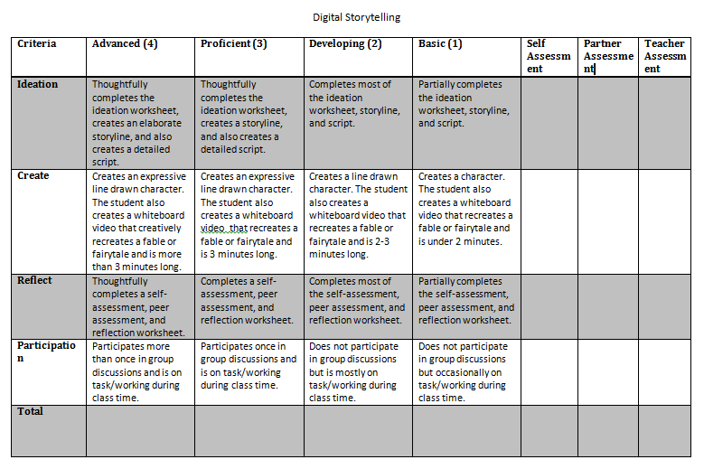

8/9/15 Fahey

